/*July 24*/

/* like clause*/

select ename from emp where ename like 'a%i' and (designation='ceo' and city in('pune','mumbai','nagpur'));

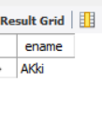

select * from emp;

select * from emp where email like '%.%' and (salary between 10000 and 20000 or eno in(1,3,4));

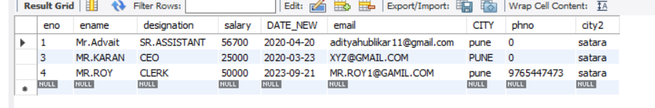

select ename,designation,phno from emp where ename like '___A%t' and( email like '%@%.%');

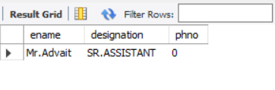

/*order by clause*/

select * from emp where ename like '______' order by ename desc;

